**Transfer Learning**

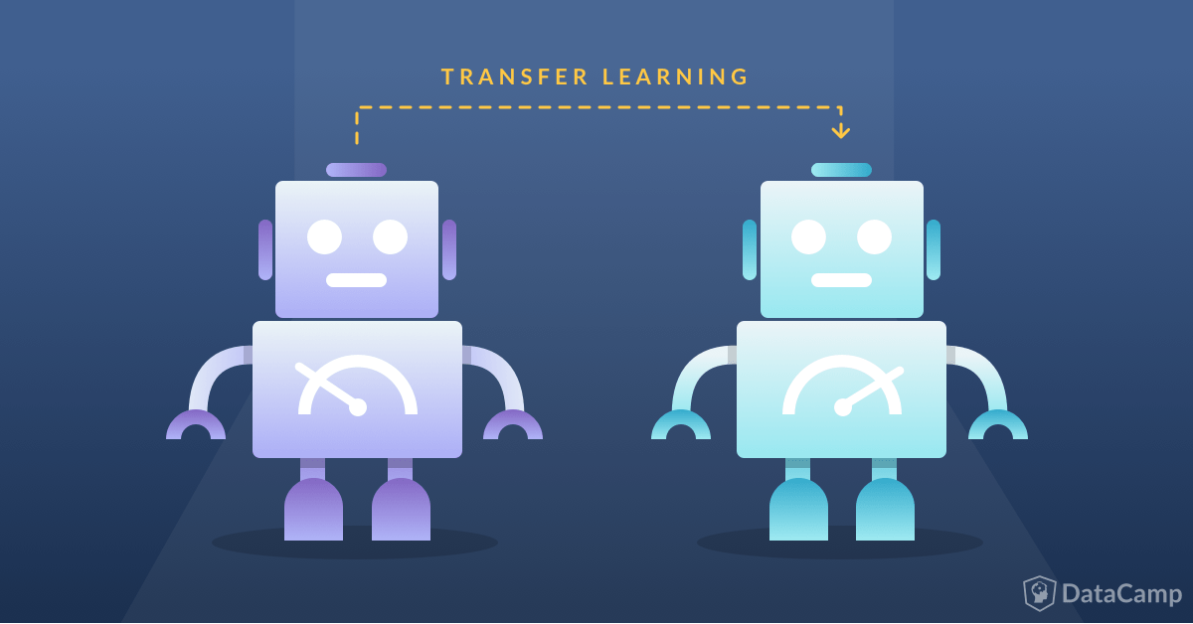

A visual representation of transfer learning.

Imagine you’ve just started a company, and you want to implement AI image recognition to help people differentiate between the different types of birds in the wild. This task is **very monumental**, especially for a company with **little to no resources** and money. It seems the only way to get around this is to just blatantly copy someone else’s model, but that’ll make it difficult for you to optimize the accuracy to your specific problem.

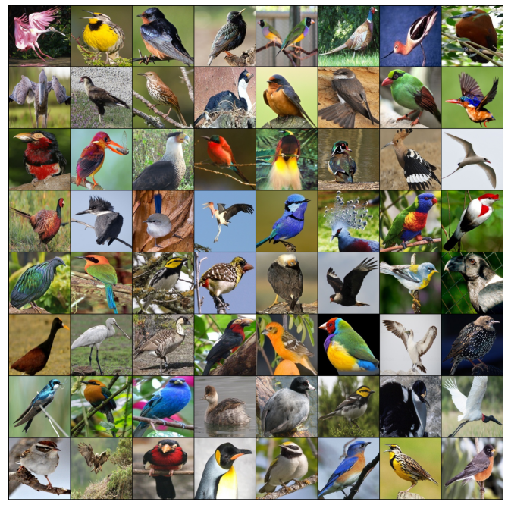

                Examples of images that can be passed into the secondary model.

**Transfer learning**is a machine learning method where a model that has already been developed is reused as the starting point for another model. This fits the problem we had above perfectly! You can take a high-accuracy image classification model that is already trained, and you can apply it to your bird classification problem!

Instead of training the model from scratch, transfer learning allows you to start at a pretty well-trained model and optimize it for your problem. Think about your original predicament as studying for a test without a study guide, and transfer learning as being that study guide for you. Although it doesn’t solve your problem outright, it definitely makes it easier for you to find the solution to your problem.

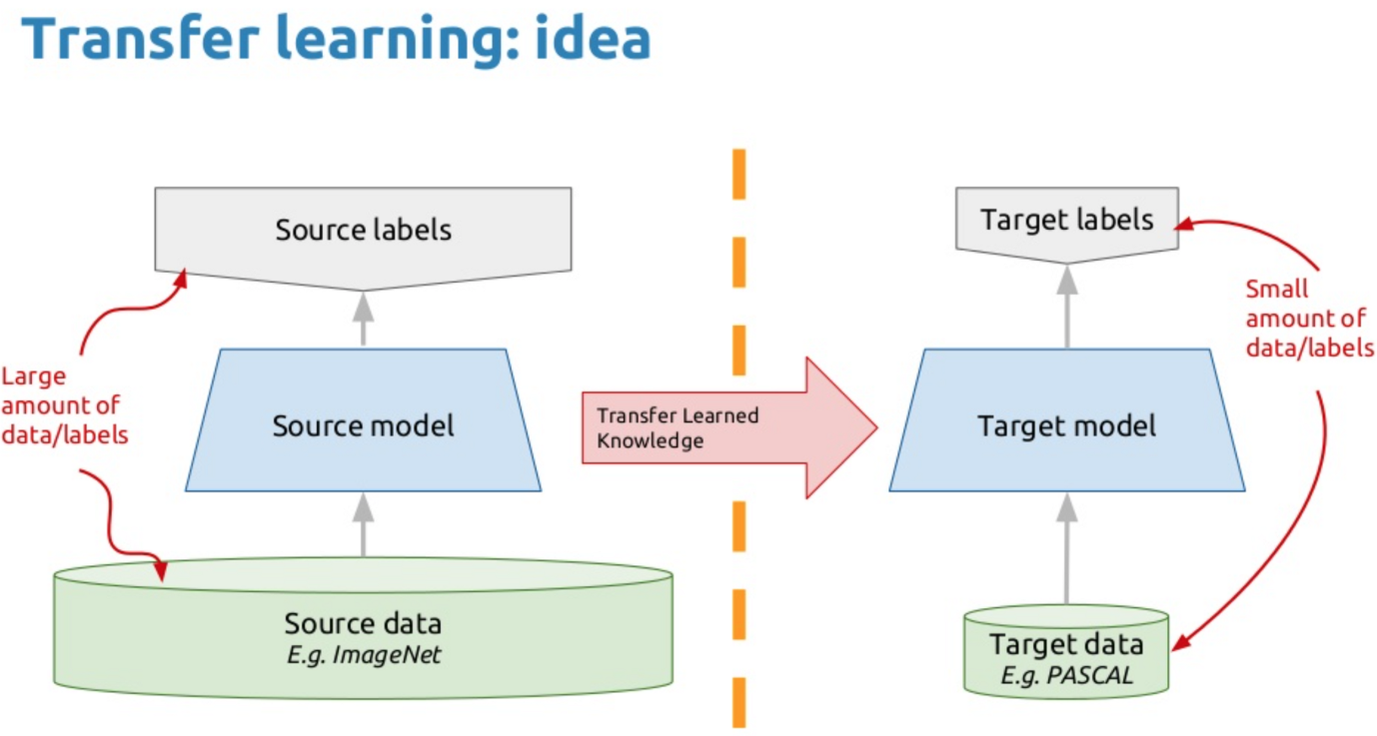

Basic representation of a transfer learning model.

**There are three steps to using transfer learning:**

* **Choose source model**. Choose a source model from a list of already trained models online. This can be found from a variety of places from past projects you’ve completed to other research institutions that have open-source AI models.
* **Use model**. Integrate your model with your current problem, and use the source model as a starting point for your true goal. You don’t have to use every part of the model, depending on what you’re attempting to do in the ending.
* **Tune model.**The model has to be adapted to fit what you’re attempting to solve. This can include a variety of optimizations and additions, such as choosing a different output layer or making different hidden layers.

**Terminology**

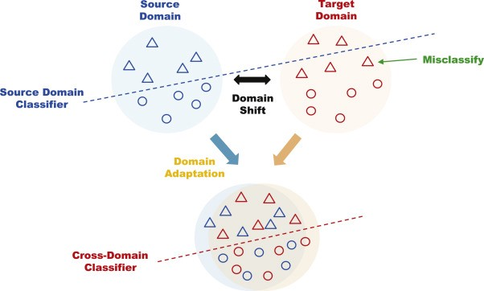

How a cross-domain adaptation transfer learning model works.

Because transfer learning has so many different methods of implementation, there are a variety of terms to keep in mind. Here are some common terms that you will hear:

* **Cross-domain adaptation:** This is when the feature spaces of the source and secondary domains are different. An example of this would be when two documents are written in different languages. This is commonly referred to as cross-lingual adaptation in NLP.
* **Domain adaptation:** This is when, for example, two documents, would discuss different topics, but would still have the same underlying language. This would be used to refer to transfer learning where a large domain shift is needed, but not as large as cross-domain adaptation.
* **Label alteration:** This is when the labels/outputs of the secondary and source model are different.
* **Label unbalance:**This is when the source and target documents are unbalanced with regards to the number of classes. An example of this would be the example in the introduction. Note that label alteration and label unbalance are very similar to one another.

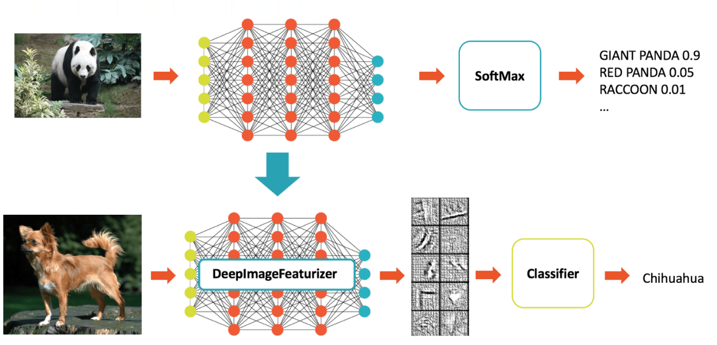

Example of transfer learning for NLP

**Automated Machine Learning**

Automated machine learning, also referred to as automated ML or AutoML, is the process of automating the time consuming, iterative tasks of machine learning model development. It allows data scientists, analysts, and developers to build ML models with high scale, efficiency, and productivity all while sustaining model quality. Automated ML in Azure Machine Learning is based on a breakthrough from our Microsoft Research Division.

Traditional machine learning model development is resource-intensive, requiring significant domain knowledge and time to produce and compare dozens of models. With automated machine learning, you'll accelerate the time it takes to get production-ready ML models with great ease and efficiency.

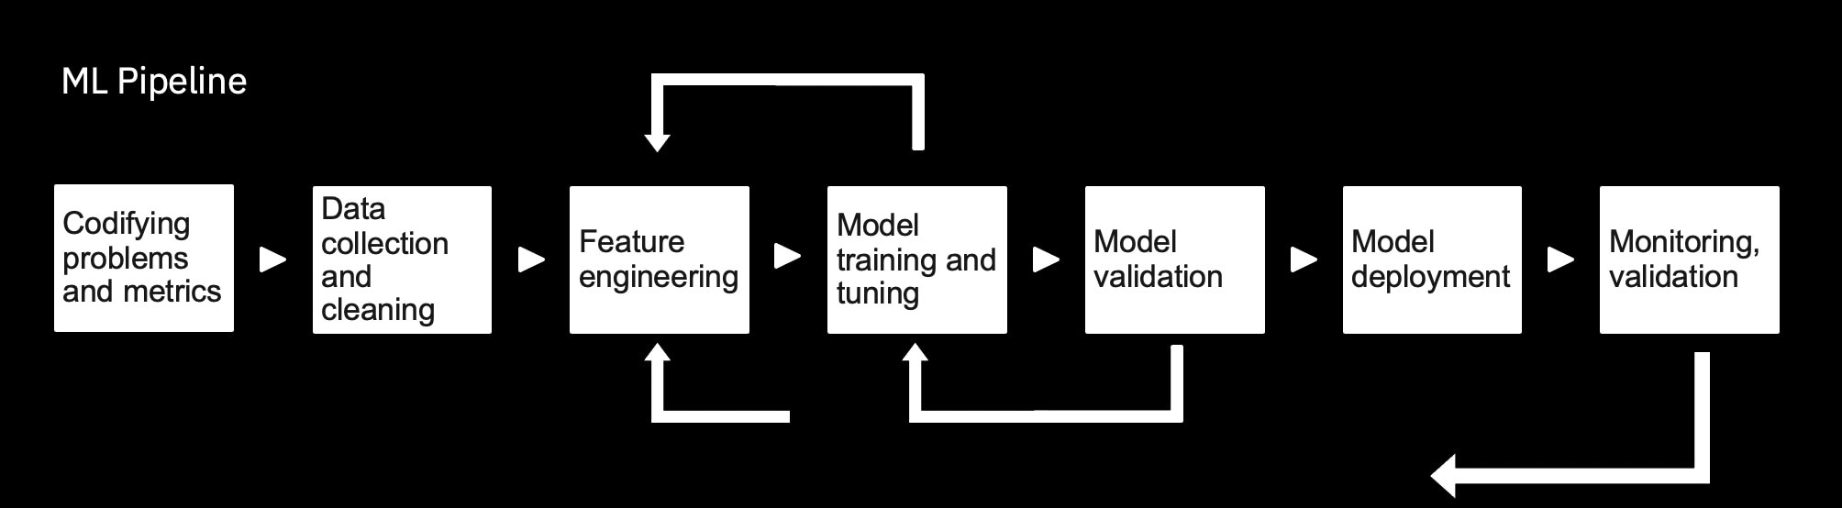

**Automated ML vs Custom Modeling**

|  |  |
| --- | --- |
| Automated Machine learning | Custom Modeling |
| +Easy to get started | +Completed customizability |
| +Robust Enterprise support | +Unlimited use cases |
| +Cheap for quick development | +Full control over parameter tuning |
| -Limited use cases | -Expensive to get started |
| -Difficult to extend | -Requires ML expertise |
| -Data is accessible to provider | -Limited means of external support |

**Transfer Learning and Automated Machine Learning Summary**

* Transfer learning uses knowledge from previous models
* Pretrained models can be found online for use with transfer learning.
* Automated ML makes it easy to create models.
* For more complex models a custom development may be required.

**Outro**

A machine learning models are defined by the architecture and the training data used to train them in order to use machine learning models in production we want to thoroughly evaluate the performance.so we are aware of the models and how it's likely to perform when deployed. In machine learning, there certain tools such as transfer learning and automated ML that we can use as aids to help us build model faster.